Get app
We build Enterprise AI. We teach what we learn. Join 100K+ AI practitioners on Towards AI Academy. Free: 6-day Agentic AI Engineering Email Guide: https://email-course.towardsai.net/
Follow publication

https://pub.towardsai.net/building-an-ai-agent-with-model-context-protocol-mcp-a-complete-guide-37b8f6cd7b2b

Building an AI Agent with Model Context Protocol (MCP): A Complete Guide

From theory to practice: Learn how Model Context Protocol (MCP) solves AI integration challenges while building a weather and search agent with FastMCP, LangGraph, and OpenAI
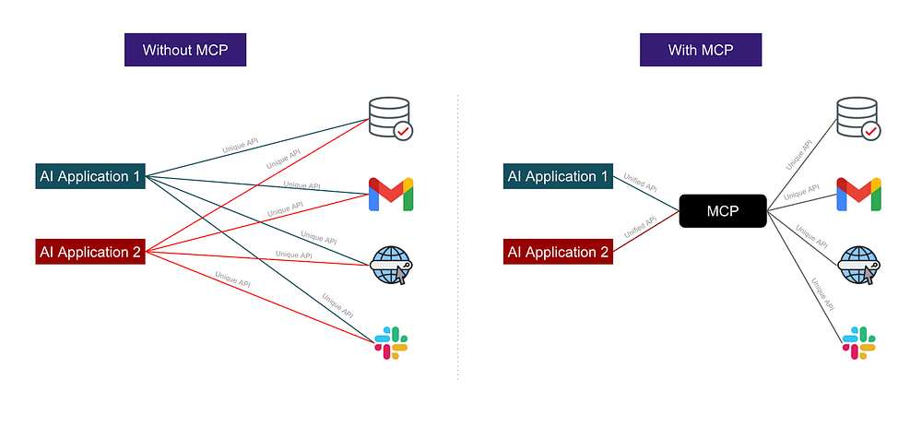
Model Context Protocol (MCP) [Image by Alpha Iterations]
Non-members please read the story here for free.

Analogy
We all know the “Phone a Friend” lifeline in Kaun Banega Crorepati (KBC). [Indian version of, Who wants to be a Millionaire?]
But imagine if KBC existed before telephones were invented.
Without Telephone:
In a telephone-less world, if KBC wanted contestants to “phone” a friend, the show would have to:
- Bring the friend physically to the studio
- Prepare room, Set up mics, headphones, wiring
- Repeat this for every single contestant
Every friend → separate setup
With Telephone:
Once telephones exist, everything changes.
KBC no longer needs elaborate setups.
The contestant just:
- Picks up the phone
- Dials their friend
- Talks instantly
No special room, No special Setup.
That’s exactly what MCP (Model Context Protocol) is doing for LLM/AI Applications.
Without MCP:
- Every tool needed its own custom integration
- No standard way for models to “talk” to tools
- Everything had to be manually wired together
With MCP:
- Any AI model can “dial” any MCP-compatible tool
- As long as it knows the tool’s schema (like having a phone number)
- No more one-off integrations
- Everything uses one standard protocol

Introduction
In the rapidly evolving world of AI and large language models, one of the biggest challenges has been connecting these powerful models to real-world data and tools. Enter Model Context Protocol (MCP), introduced by Anthropic in 2024, a groundbreaking open standard that’s changing how AI applications interact with external systems.
In this comprehensive guide, we’ll explore MCP through a hands-on project where we build a multi-tool AI agent that can fetch weather data and perform web searches. Whether you’re an AI enthusiast, developer, or just curious about the future of AI integration, this article will give you practical insights into building MCP-powered applications.

Why MCP?:
MCP acts as a bridge between AI models and the tools they need, making it possible to build sophisticated AI agents that can seamlessly interact with the outside world.
MCP makes AI more connected, powerful, and ready for enterprise deployment by eliminating integration silos and standardizing how context is shared between models and external systems. Major problems that MCP addresses are:
- Common Language
Before MCP: Each tool had its own way of talking to AI models.
After MCP: All tools use one shared language, making communication easy.
- Easy Integration
Before MCP: Developers built separate connectors for every app.
After MCP: One standard connection works for all tools.
- Safe Tool Access
Before MCP: AI could not safely access external tools and data.
After MCP: AI can securely use many tools through one protocol.
- Reusable Tools
Before MCP: Tools worked only with specific models.
After MCP: Any MCP tool works with any MCP-compatible model.
- Faster Innovation
Before MCP: Everyone reinvented the wheel, slowing progress.
After MCP: Shared standard speeds up building and innovation.

Key Components of MCP (Model Context Protocol)
Press enter or click to view image in full size
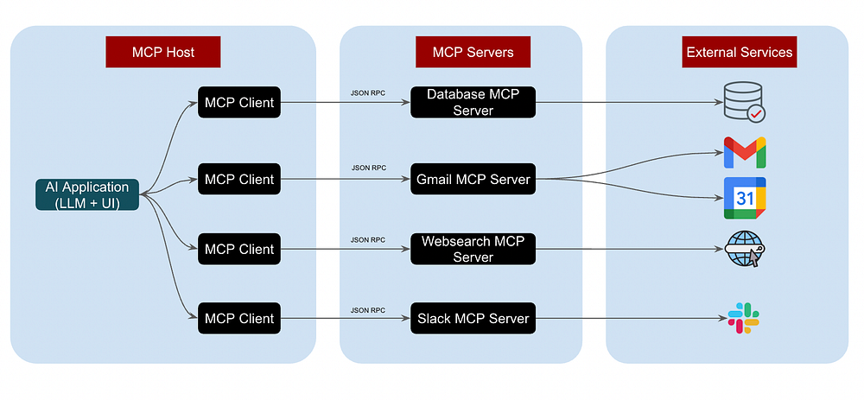
Architecture of MCP (Model Context Protocol) [Image by Alpha Iterations]

1. MCP Host
- This is the AI application / agent environment where user interaction happens (for example, Claude Desktop, an IDE, or a conversational app).
- The host orchestrates multiple clients, manages workflows, and decides how and when to call various MCP clients.

2. MCP Client
The MCP Client operates inside the host application and manages communication with MCP Servers. Its responsibilities include:
- Establishing connections to the MCP servers
- Requesting information about available capabilities
- It translates the model’s intentions (or “requests”) into structured MCP protocol messages and forwards it to the server.
- Handling and interpreting the returned responses

3. MCP Server
The MCP Server makes specific capabilities available and provides access to different data sources and tools. Each tool (database, API, filesystem, CRM, email, etc.) is an MCP Server. One server can have multiple tools. Below are the responsibilities of MCP Server.
- It waits for incoming requests
- Executes the function or retrieves the data
- Returns structured results to the Client
Each server exposes three main categories of capabilities:
- Tools: Functions that allow LLMs to take actions (e.g., run a search, call an API)
- Resources: Data or content accessible to the LLM (documents, user data, structured information)
- Prompts: Reusable templates or workflows that guide the generation of specific outputs

4. Protocol
- MCP defines a data layer using JSON-RPC 2.0 for communication between clients and servers.
- It defines message types, semantics, and primitives for “tools,” “resources,” “prompts,” and notifications.
- Lifecycle management: MCP handles connection setup, capability negotiation (i.e., figuring out what the server supports), and clean termination.
- Security: often uses OAuth (or other authentication) to authorize client-server interactions.

5. Transport Layer
Abstracts how messages are sent. MCP supports different transport mechanisms.
Two common transports:
- STDIO: (Standard Input/Output) for local, synchronous setup (e.g., when server is running locally).
- Server-Sent Events (SSE): for remote servers, enabling streaming or real-time updates.

What we are building:
In this setup, we built a LangGraph agent that:
- Integrates MCP tools (web-search, weather) for external actions.
- Uses OpenAI LLM for routing and generating responses.
- Handles stateful conversations with structured workflows.
- Can be extended with additional tools or more complex graphs.
With this architecture, you can now build multi-tool AI assistants that reason, act, and respond dynamically.
Press enter or click to view image in full size
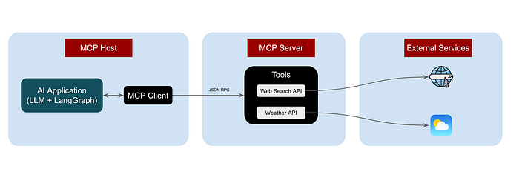
Model Context Protocol Implementation
Press enter or click to view image in full size
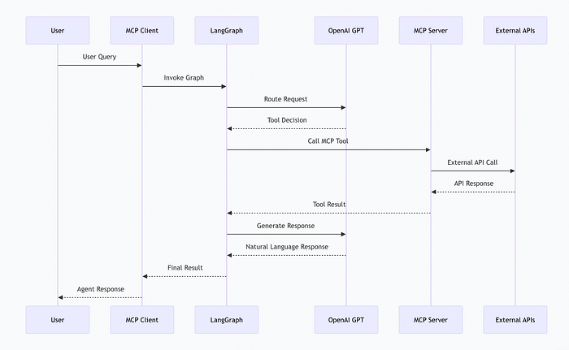
Flow between User Query → Final Response using MCP [Image by Author]
Let’s get started:

Project Structure
Please refer complete end to end github repo here.
mcp-server/
├── mcp_server.py # MCP server implementation (FastMCP)
├── mcp_client.py # MCP client + LangGraph agent
├── mcp-server.ipynb # Jupyter notebook for testing
├── requirements.txt # Python dependencies
├── .env # Environment variables (API keys)
└── README.md

1. Setup & Installation

1.1 Clone the Repository
Run this in your terminal to clone the repository
#Terminal
git clone https://github.com/alphaiterations/mcp-server
cd mcp-server

1.2 Install Dependencies
Run this in your terminal to install the dependencies
#Terminal
pip install -r requirements.txt

1.3 Configure Environment Variables
Create a .env file in the project root:
#.env
# OpenAI API Key (required)
OPEN_AI_KEY=your_openai_api_key_here
# Serper API Key (required for web search)
SERPER_API_KEY=your_serper_api_key_here
Getting API Keys:
- OpenAI: https://platform.openai.com/api-keys
- Serper: https://serper.dev/ (free tier available)

2. Setting up the MCP Server:
We MCP Server using mcp_server.py file. This script creates a production-ready MCP tool server with two fully usable tools:
get_weather: Returns real-time weather for any city
web_search: Performs AI-friendly Google-style searches
Both tools automatically validate input, handle errors cleanly, and return structured JSON — making them ideal for LLM integration.

2.1 Importing the Libraries
We import the libraries, fastmcp, pydand
#mcp_server.py
from fastmcp import FastMCP
from pydantic import BaseModel
import os
import requests
from dotenv import load_dotenv

2.2 API Configuration
This reads API keys from environment variables. OPENWEATHER_API_KEY is optional because the weather tool uses a free fallback service.
#mcp_server.py
# ---------------- API CONFIGURATION ----------------
SERPER_API_KEY = os.getenv("SERPER_API_KEY")
OPENWEATHER_API_KEY = os.getenv("OPENWEATHER_API_KEY", "") # Optional, using free weather API

2.3 Creating the MCP Server
#mcp_server.py
mcp = FastMCP("multi-tool-server")
This initializes a new MCP server named “multi-tool-server”.
Every function registered below becomes a callable agent tool.

2.4 Weather Tool
#mcp_server.py
@mcp.tool()
def get_weather(input: WeatherInput):
"""Get current weather for a city using WeatherAPI.com (free tier)"""
try:
# Using WeatherAPI.com free tier (no API key needed for basic usage)
# Alternative: OpenWeatherMap if you have API key
url = f"https://wttr.in/{input.city}?format=j1"
response = requests.get(url, timeout=5)
if response.status_code == 200:
data = response.json()
current = data["current_condition"][0]
location = data["nearest_area"][0]
weather_info = {
"location": f"{location['areaName'][0]['value']}, {location['country'][0]['value']}",
"temperature": f"{current['temp_C']}°C / {current['temp_F']}°F",
"condition": current["weatherDesc"][0]["value"],
"humidity": f"{current['humidity']}%",
"wind": f"{current['windspeedKmph']} km/h",
"feels_like": f"{current['FeelsLikeC']}°C"
}
return weather_info
else:
return {"error": f"Could not fetch weather for {input.city}"}
except Exception as e:
return {"error": f"Weather API error: {str(e)}"}
This registers a weather lookup tool accessible through MCP.
Key behavior inside:
- Uses wttr.in, a free weather API (no key required).
- Extracts human-friendly fields like temperature, humidity, wind speed.
- Wraps everything in a try/except block for safe failure handling.
Example:
Input: {"city": "Mumbai"}
Output: {
"location": "Mumbai, India",
"temperature": "28°C / 82°F",
"condition": "Partly cloudy",
"humidity": "70%",
"wind": "15 km/h"
}

2. 5 Web Search Tool
#mcp_server.py
@mcp.tool()
def web_search(input: WebSearchInput):
"""Search the web using Serper API"""
if not SERPER_API_KEY:
return {"error": "SERPER_API_KEY not configured"}
try:
url = "https://google.serper.dev/search"
headers = {
"X-API-KEY": SERPER_API_KEY,
"Content-Type": "application/json"
}
payload = {"q": input.query, "num": 5}
response = requests.post(url, json=payload, headers=headers, timeout=10)
if response.status_code == 200:
data = response.json()
results = []
# Extract organic results
for item in data.get("organic", [])[:5]:
results.append({
"title": item.get("title"),
"link": item.get("link"),
"snippet": item.get("snippet")
})
# Include knowledge graph if available
knowledge = data.get("knowledgeGraph", {})
return {
"query": input.query,
"results": results,
"knowledge_graph": knowledge.get("description", "") if knowledge else None
}
else:
return {"error": f"Serper API error: {response.status_code}"}
except Exception as e:
return {"error": f"Web search error: {str(e)}"}
This registers a Google-like search tool powered by the Serper API.
Highlights:
- Validates API key existence before running.
- Sends a POST request with the query and retrieves up to 5 results.
- Parses: Title, Link and Snippet
If anything fails, it returns a structured JSON error message.
Example:
Input: {"query": "latest news about AI"}
Output: {
"query": "latest news about AI",
"results": [
{
"title": "AI Breakthrough...",
"link": "https://...",
"snippet": "..."
}
]
}

2.6 Server Entry Point
#mcp_server.py
if __name__ == "__main__":
print("🔥 MCP server running...")
mcp.run()
This block starts the MCP server when the script is executed directly.
Once running, tools such as get_weather and web_search become callable by:
- AI agents
- LangChain / LLM frameworks
- Any MCP-compatible client

3. Setting up the MCP Client

3.1 Dependencies and Environment Setup
# mcp_client.py
import subprocess, json, sys, threading, time
from langgraph.graph import StateGraph, END
from typing import TypedDict, Any, Dict
from openai import OpenAI
from dotenv import load_dotenv
import os
# Load environment variables
load_dotenv()
Here we import:
- LangGraph: For building state-based agent workflows.
- OpenAI: To handle LLM reasoning and conversation.
- subprocess/threading: To launch and communicate with an MCP server.
- dotenv/os: For safely loading API keys.

3.2 Initializing OpenAI Client
# mcp_client.py
client = OpenAI(api_key=os.getenv("OPEN_AI_KEY"))
We create an OpenAI client using the API key from environment variables.

3.3 Launching the MCP Server
# mcp_client.py
server = subprocess.Popen(
[sys.executable, "mcp_server.py"],
stdin=subprocess.PIPE,
stdout=subprocess.PIPE,
stderr=subprocess.PIPE,
text=True,
bufsize=1
)
print("🔗 Connected to MCP server")
Here we spawn a MCP server subprocess, which exposes the tools we created earlier (get_weather and web_search).
We also use a thread to read startup messages without blocking the main program:
# mcp_client.py
def read_startup():
while True:
line = server.stderr.readline()
if not line:
break
if "Starting MCP server" in line:
break
startup_thread = threading.Thread(target=read_startup, daemon=True)
startup_thread.start()
time.sleep(1)

3.4 MCP Communication Helpers
We define functions to send requests and notifications over the MCP JSON-RPC protocol:
# mcp_client.py
def send_request(method: str, params: Dict = None):
global request_id
request_id += 1
req = {"jsonrpc": "2.0", "id": str(request_id), "method": method}
if params:
req["params"] = params
server.stdin.write(json.dumps(req) + "\n")
server.stdin.flush()
return server.stdout.readline().strip()
def send_notification(method: str, params: Dict = None):
req = {"jsonrpc": "2.0", "method": method}
if params:
req["params"] = params
server.stdin.write(json.dumps(req) + "\n")
server.stdin.flush()
We then initialize the MCP connection:
# mcp_client.py
init_response = send_request("initialize", {
"protocolVersion": "2024-11-05",
"capabilities": {},
"clientInfo": {"name": "mcp-client", "version": "1.0.0"}
})
send_notification("initialized")

3.4 Calling MCP Tools
# mcp_client.py
def call_mcp_tool(tool: str, args: Dict):
global request_id
request_id += 1
req = {
"jsonrpc": "2.0",
"id": str(request_id),
"method": "tools/call",
"params": {"name": tool, "arguments": {"input": args}},
}
server.stdin.write(json.dumps(req) + "\n")
server.stdin.flush()
response = server.stdout.readline().strip()
try:
resp_data = json.loads(response)
return resp_data.get("result") or f"Error: {resp_data.get('error')}"
except:
return response
This function allows the agent to call any tool registered in the MCP server with parameters.

3.5 Agent State Graph
We define a state schema using TypedDict:
# mcp_client.py
class S(TypedDict):
msg: str
tool_result: Any
result: str
Then we implement agent logic using two main functions:
1️⃣ Routing Requests to Tools
# mcp_client.py
# ---------------- AGENT LOGIC ----------------
def route_request(state: S):
"""Use LLM to determine which tool to use and extract parameters"""
# Ask LLM to analyze the request and decide on tool usage
routing_prompt = f"""Analyze this user request and determine which tool to use:
User request: {state["msg"]}
Available tools:
1. get_weather - Get current weather for a city. Requires: city name
2. web_search - Search the web for information. Requires: search query
Respond in JSON format with:
{{
"tool": "get_weather" | "web_search" | "none",
"parameters": {{"city": "..."}} or {{"query": "..."}} or null,
"reasoning": "brief explanation"
}}
Only use tools if clearly needed. For general conversation, use "none"."""
response = client.chat.completions.create(
model="gpt-4o-mini",
messages=[
{"role": "system", "content": "You are a tool routing assistant. Analyze user requests and determine which tool to use. Always respond with valid JSON."},
{"role": "user", "content": routing_prompt}
],
temperature=0.3,
response_format={"type": "json_object"}
)
try:
routing_decision = json.loads(response.choices[0].message.content)
tool = routing_decision.get("tool")
params = routing_decision.get("parameters")
print(f"🤖 Routing decision: {routing_decision.get('reasoning')}")
if tool == "get_weather" and params:
result = call_mcp_tool("get_weather", params)
return {"msg": state["msg"], "tool_result": result}
elif tool == "web_search" and params:
result = call_mcp_tool("web_search", params)
return {"msg": state["msg"], "tool_result": result}
else:
return {"msg": state["msg"], "tool_result": None}
except Exception as e:
print(f"⚠️ Routing error: {e}")
return {"msg": state["msg"], "tool_result": None}
- The agent uses an LLM to decide which tool (get_weather, web_search, or none) is appropriate.
- It returns parameters required by the chosen tool.
- If no tool is needed, the agent continues with general conversation.
2️⃣ Generating Natural Language Responses
This function ensures the agent responds naturally, whether it uses tool data or not.
# mcp_client.py
def generate_response(state: S):
"""Use OpenAI to generate a natural language response"""
if state.get("tool_result") is None:
# No tool was used, direct LLM response
response = client.chat.completions.create(
model="gpt-4o-mini",
messages=[
{"role": "system", "content": "You are a helpful assistant."},
{"role": "user", "content": state["msg"]}
],
temperature=0.7
)
return {
"msg": state["msg"],
"tool_result": state.get("tool_result"),
"result": response.choices[0].message.content
}
# Format tool result for LLM
tool_data = json.dumps(state["tool_result"], indent=2)
response = client.chat.completions.create(
model="gpt-4o-mini",
messages=[
{"role": "system", "content": "You are a helpful assistant. Use the tool results provided to answer the user's question in a natural, conversational way. Be concise but informative."},
{"role": "user", "content": f"User question: {state['msg']}\n\nTool results:\n{tool_data}\n\nProvide a helpful answer based on this information. Please limit your answer in 100 words."}
],
temperature=0.7
)
return {
"msg": state["msg"],
"tool_result": state["tool_result"],
"result": response.choices[0].message.content
}
🗺 Building the LangGraph Workflow
# mcp_client.py
g = StateGraph(S)
g.add_node("route", route_request)
g.add_node("respond", generate_response)
g.set_entry_point("route")
g.add_edge("route", "respond")
g.add_edge("respond", END)
graph = g.compile()
- Entry point: route → decides tool usage.
- Respond node: formats output and returns answer to the user.
- Graph edges define the workflow from routing → responding → END.
Graph Visualization
# mcp_client.py
# ---------------- SAVE GRAPH VISUALIZATION ----------------
try:
# Generate and save the graph as PNG
png_data = graph.get_graph().draw_mermaid_png()
with open("langgraph_diagram.png", "wb") as f:
f.write(png_data)
print("📊 Graph visualization saved as 'langgraph_diagram.png'\n")
except Exception as e:
print(f"⚠️ Could not generate graph visualization: {e}")
print("Note: Install graphviz system dependency if needed: brew install graphviz\n")
Press enter or click to view image in full size
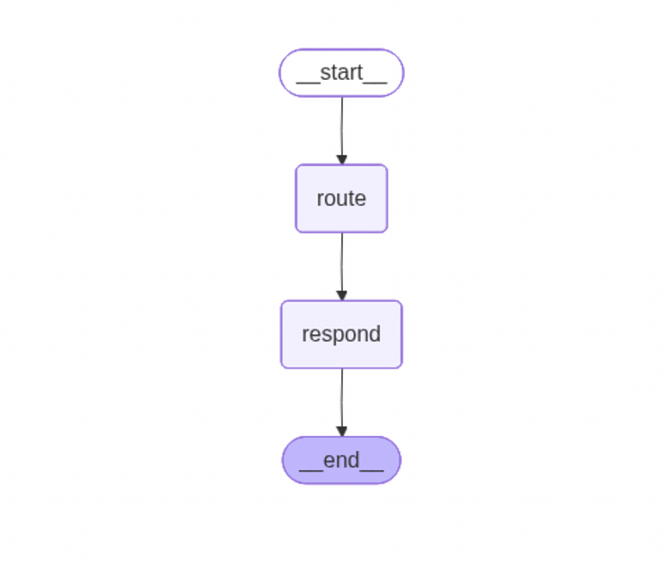
LangGraph Flow [Image by Author]

4. Testing the Agent
# mcp_client.py
tests = [
"What's the weather in Mumbai?",
"Search for latest news about AI",
]
for t in tests:
result = graph.invoke({"msg": t})
print(f"AGENT: {result['result']}\n")
Run below command in your terminal:
# Terminal
python mcp_client.py
This will run the python file mcp_client.py and will give your the output of each test query.

Query 1: What is the Weather in Mumbai?
================================================================================
USER: What's the weather in Mumbai?
================================================================================
🤖 Routing decision: The user is asking for the current weather in Mumbai, which requires the get_weather tool.
AGENT: The current weather in Mumbai (Bombay) is 29°C (85°F) with smoky conditions. The humidity is at 33%, and there's a wind speed of 15 km/h. It feels like 32°C. If you're heading out, be mindful of the smoke and stay hydrated!
Here get_weather tool is used.

Query 2: Search for latest news about AI
================================================================================
USER: Search for latest news about AI
================================================================================
🤖 Routing decision: The user is requesting information about the latest news, which requires a web search.
AGENT: Here are some of the latest updates in AI:
1. **SoftBank Chief** predicts that Artificial Superintelligence (ASI) will emerge within the next decade. [Read more](https://www.artificialintelligence-news.com/).
2. **Chinese hackers** are reportedly using Anthropic's AI for automating cyberattacks, showcasing a troubling trend in AI-enabled hacking. [Details here](https://www.wsj.com/tech/ai?gaa_at=eafs&gaa_n=AWEtsqe6_smhBCGQiDzNepJqC6o3y7PhzDWoVgMhJZGDlbwMlAYPmvdgcIPG&gaa_ts=69189ea0&gaa_sig=qnJpVRszm4Y6fAKLtKZrrhXemUfohwfFMNBiCB3KvfR27ZVin1pFM5wC5RChseRXHH0r_l6_oX46pJKkaceNWg%3D%3D).
3. **MIT students** are developing AI tools to be more flexible and truthful. [Explore further](https://news.mit.edu/topic/artificial-intelligence2).
For more news, check out [TechCrunch](https://techcrunch.com/category/artificial-intelligence/) and [Google's AI blog](https://blog.google/technology/ai/google-ai-updates-october-2025/).
Here web_search tool is used.
Here is the complete flow in a Markdown format:
┌─────────────────────────────────────────────────────────────┐
│ USER INPUT │
│ "What's the weather in Mumbai?" │
└──────────────────────┬──────────────────────────────────────┘
│
▼
┌─────────────────────────────────────────────────────────────┐
│ LANGGRAPH AGENT │
│ ┌──────────────┐ ┌──────────────┐ │
│ │ Routing │────────▶│ Response │ │
│ │ Node │ │ Node │ │
│ └──────┬───────┘ └──────────────┘ │
│ │ │
│ │ Uses OpenAI to determine: │
│ │ - Which tool to use │
│ │ - Extract parameters │
└─────────┼─────────────────────────────────────────────────────┘
│
▼
┌─────────────────────────────────────────────────────────────┐
│ MCP CLIENT │
│ - Manages connection to MCP server │
│ - Sends JSON-RPC requests │
│ - Receives and processes responses │
└──────────────────────┬──────────────────────────────────────┘
│
│ JSON-RPC over STDIO
│
▼
┌─────────────────────────────────────────────────────────────┐
│ MCP SERVER │
│ ┌──────────────┐ ┌──────────────┐ │
│ │ get_weather │ │ web_search │ │
│ │ Tool │ │ Tool │ │
│ └──────────────┘ └──────────────┘ │
│ │
│ Built with FastMCP framework │
└──────────────────────┬──────────────────────────────────────┘
│
▼
┌─────────────────────────────────────────────────────────────┐
│ EXTERNAL APIs │
│ • wttr.in (Weather API) │
│ • Serper API (Web Search) │
└─────────────────────────────────────────────────────────────┘

Conclusion:
In this tutorial, we built a multi-tool MCP server that can handle both real-time weather lookups and AI-powered web searches. Using FastMCP, we created modular, reusable tools with clear input validation via Pydantic and robust error handling.
This setup demonstrates how easily you can expose real-world functionality like APIs or web searches to LLMs or other AI agents. By separating concerns into discrete tools, you gain:
- Scalability: add more tools without touching existing ones.
- Safety: structured inputs prevent invalid requests.
- Flexibility: switch APIs or data sources without changing the interface.
Whether you’re building AI assistants, chatbots, or research agents, this pattern lets you combine multiple capabilities into a single, maintainable server.
The next step? Extend your MCP server with additional tools like currency conversion, text summarization, or sentiment analysis and watch your AI ecosystem grow smarter and more versatile.

Reference:
- https://github.com/modelcontextprotocol/servers
- https://www.anthropic.com/news/model-context-protocol
- https://modelcontextprotocol.io/docs/learn/architecture
- https://diamantai.substack.com/p/model-context-protocol-mcp-explained
- https://wttr.in/api
- https://serper.dev/
Please refer to my other articles:
- Build Agentic RAG using LangGraph
- Practical Guide to Using ChromaDB for RAG and Semantic Search
- Reading Images with GPT-4o: The Future of Visual Understanding with AI
- Agentic AI Project: Build Mini Perplexity AI : Step by Step Guide [Code Included]
- Agentic AI: Build ReAct Agent using LangGraph
- Agentic AI Project: Build a multi-agent system with LangGraph and OpenAI API
- Agentic AI Project: Build Multi-Agent Text2SQL Chatbot for Ecommerce Database
- TOON vs JSON: A Comprehensive Performance Comparison
- Building an Intelligent Resume Transformation Agent Powered by LangGraph and gpt-4o-mini
- Agentic AI Project: MLflow Observability for Generative AI — A Deep Dive with Text2SQL + RAG + WebSearch using LangGraph, Open AI

